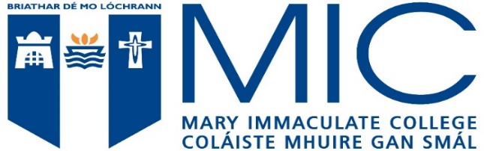

Appendix 2 Minimum Qualifications in GCSE and GCE AS and A Level Examinations for admission to the Bachelor of Education Degree Course General
- Six subjects must be presented, at least three subjects at GCE A Level and the remaining subjects at GCE AS or GCSE level. The six subjects must include Irish, English and Mathematics.
- A subject may be counted from only one of the examinations, GCSE, GCE AS Level or GCE A Level.
- Only subjects taken at one sitting of a particular examination, GCSE, GCE AS Level or GCE A Level, will be accepted. Examinations taken in the same academic year are regarded as the same sitting.

Specific Requirements in Irish, English & Mathematics
- Grade C at GCE A level in at least three subjects, including Irish
- Grade C at GCSE Level in both English and English Literature, or Grade B at GCSE Level in either English or English Literature.
- Grade D at GCSE Level in Additional Mathematics or Grade C at GCSE Level in Mathematics
- Grade C in one other subject at GCSE level
Applicants must satisfy the matriculation requirements of the University to which the Higher Education Institution is affiliated.

